IN4230 Home Exam 1 Design Document
A discussion of how MIP is different than IPv4, and how its performance compares to IPv4 (one to two paragraphs).
The most prominent difference difference between MIP and IPv4 is the smaller address range. This makes it simpler to address using the MIP address directly, like we do in the home exam. This means that we don’t have to implement a form of DNS or aliasing the addresses, which is another slight performance boost on IP. A consequence of the smaller address range is that there are only 256 unique addresses. This is suitable for what is equivalent to a normal local area network for IPv4, but is obviously insufficient for any larger networks.
In addition to the smaller address range, MIP is in general much simpler, containing less header fields than IPv4, currently only supporting two upper layer protocols, and at most supporting protocols in the future without changing the format of the header. With the aforementioned simplicity there are also several performance benefits and there is less overhead with a small MIP packet than with a small IPv4 packet. Even though there is less overhead for small amounts of data, the smaller header size is less significant for large amounts of data, as the maximum length of a MIP packet is shorter than for IPv4. The max length of an IPv4 package is bytes, while the maximum size of an MIP package is 4 byte words, meaning bytes. The header size of IPv4 is 20 bytes and the header size of a MIP packet is 4 bytes, so for a maximum length IPv4 package, 0.03 % of the package will consist of the header, while for a maximum length MIP package, 0.2 % of the package will be the header.
Discuss why we need to handle the MIP-ARP protocol as a special case. Discuss alternative design choices that would allow for a cleaner implementation (two to three paragraphs).
We need to handle MIP-ARP as a special case because the routing on the link layer uses MAC addresses, which are completely separate from our own MIP addresses. There is no way for us to know which MIP address links to which MAC addresses when sending messages, without performing some kind of mapping. ARP for MIP also cannot be handled by other parts of the network stack, as they do not know the format of MIP headers. For IPv4, ARP can be implemented in the operating system or other parts of the network stack, as the the format of IPv4 headers is known.
An alternative to the current MIP-ARP implementation would be to include the mapping of MAC addresses with MIP addresses in the initial network setup. You could move from traditional ARP to gratuitous ARP, where each MIP daemon would send out a broadcast when joining the network, allowing others to map its MAC and MIP address. Since the MIP daemon already inserts received ARP requests into its cache, they would not have to send any requests to this new server. Existing servers would just respond with their own MIP addresses, allowing the new server to map the entire network. Since there is a maximum of 255 MIP addresses, there will not be any problems with overly large caches of MIP addresses. This way the daemon would not have to handle ARP when talking to nodes, and it could trust that it could just forward messages directly.
It would also be possible to for example set up something akin to a DNS server, querying it for the MAC address matching a given MIP, and keeping that temporarily in your local cache for efficiency’s sake. Each MIP daemon would then be responsible for entering its own MIP address into this server when entering the network.
A flow chart summarizing the flow of execution on both the client and server side.
See the next page for flow chart describing normal flow of a ping_client sending message to a ping_server, and getting a message back. For simplicity’s sake, the flowchart has been split into two pieces, each part of the diagram consisting of one MIP daemon and one node. The leftmost diagram is the communication between the receiver MIP daemon and the ping_server, while the rightmost part is the communication between the sender MIP daemon and the ping_client. You can visualize it as inserting the “server B” flowchart into the green circles of the “Client A” flowchart.
I have marked the parts executed by the ping_server in brown, and the parts executed by the ping_client in yellow. For simplicity’s sake, I have left out steps such as the parsing of command-line parameters and setting up raw/unix sockets.
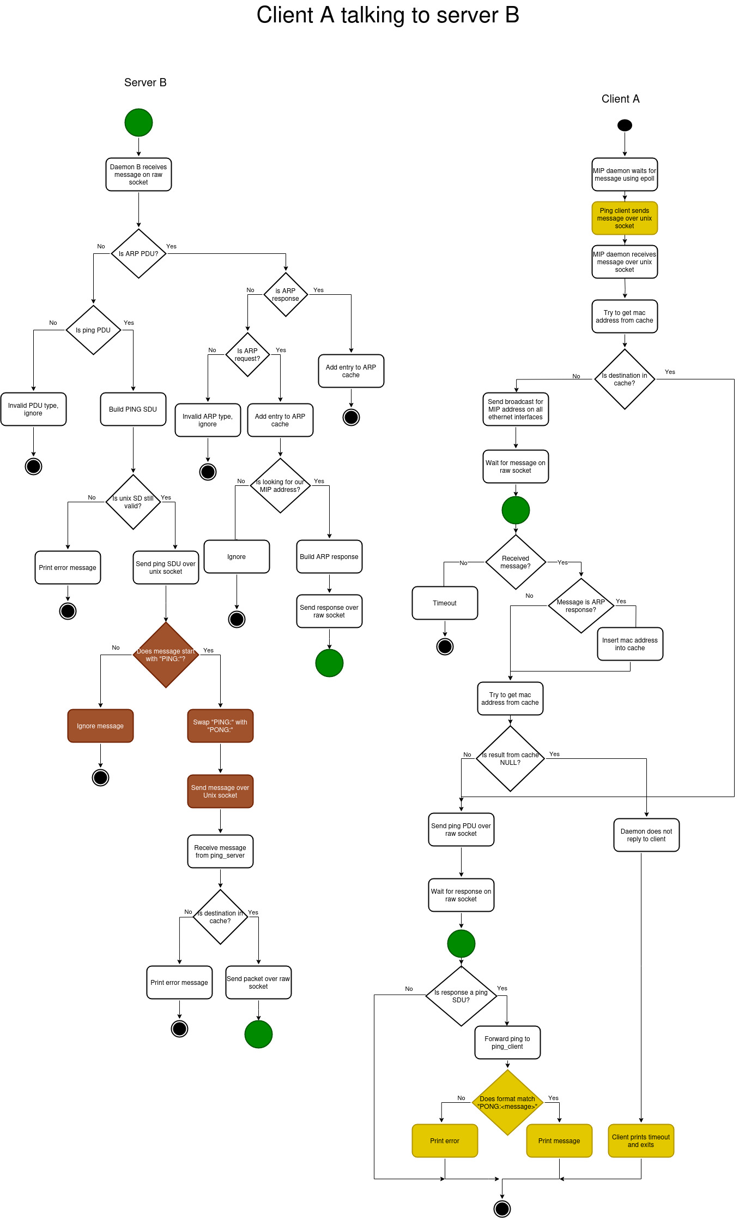

Known issues
I believe I have created a satisfactory solution to the home exam, but there are still some issues with my current implementation that I would like to discuss. First of all, the implementation needs everything to happen in order and through blocking calls. For example, when the ping_client sends a message for the first time, the MIP daemon needs to send an ARP request, read the response, send the ping packet and read the response, with every time it is receiving or sending data being a blocking call. This is done because the MIP daemon needs to keep track of which client it should return the final data to. This causes the branches in the MIP daemon main event loop to be very specific for what the expected flow is, and it causes the whole program to be vulnerable to edge cases.
For a more robust program and more code re-use it would be better to cache the destination ping_client, and find it when receiving ping data on the raw socket, this would allow the program to have more common code between talking to the ping_server and the ping_client. This would also make it easier to transition to non-blocking calls, which would make the whole program more responsive, especially when it comes to possible timeouts.
When testing my solution with the evaluation script I also discovered that the RTT of the final invocation is sometimes affected by the previous ping_client trying to reach an unreachable server. The final ping_client invocation has to wait for the MIP daemon to time out when waiting for a response to the previous ARP request, before the daemon can handle the data the next ping_client has written, the RTT therefore includes the time it has waited for the timeout, even though it originated in a completely separate ping_client. This was only apparent only sometimes, either causing the client to time out, or it showing an unusually large RTT. The best way to fix this in my MIP daemon would be to not use a blocking call when waiting for an ARP response, but this would require the daemon to cache the message it was going to send to the address it is sending an ARP request for, and resend it after the ARP response has arrived, which unfortunately I have not had time to implement.
I believe that the above problem stems from some race condition related to which order the mininet terminals open in, as when they opened in order, the MIP daemon acted as expected, but sometimes the terminal pinging the unreachable MIP address would open first or second, causing one or both of the other clients to time out, as they have to wait for the initial ARP to time out, see screenshots below. Adding a ``time.sleep(1)`` in the Python script between node A trying to ping node C, and the final command of node A pinging node B for the second time seemed to fix this, and showed the true RTT.
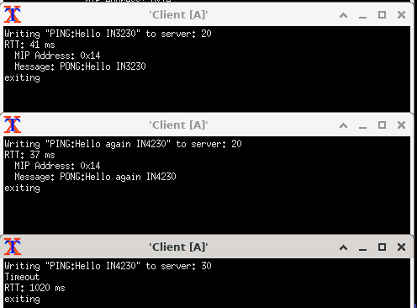Figure 1: Normal Example where client pinging unreachable server opened last
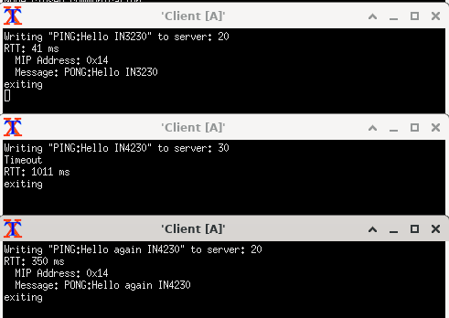Figure 2: Example race condition where terminal pinging unreachable MIP address opens second, causing the final ping_clients to have an unnaturaly long RTT

